# Topics: Descriptive Statistics and Probability

**Q1.** Look at the data given below. Plot the data, find the outliers, and find out 𝜇, 𝜎, 𝜎2.

|  |  |
| --- | --- |
| **Name of company** | **Measure X** |
| Allied Signal |  |
| Bankers Trust | 25.53% |
| General Mills | 25.41% |
| ITT Industries | 24.14% |
| J.P.Morgan & Co. | 29.62% |
| Lehman Brothers | 28.25% |
| Marriott | 25.81% |
| MCI | 24.39% |
| Merrill Lynch | 40.26% |
| Microsoft | 32.95% |
| Morgan Stanley | 91.36% |
| Sun Microsystems | 25.99% |
| Travelers | 39.42% |
| US Airways | 26.71% |
| Warner-Lambert | 35.00% |

# ANS:

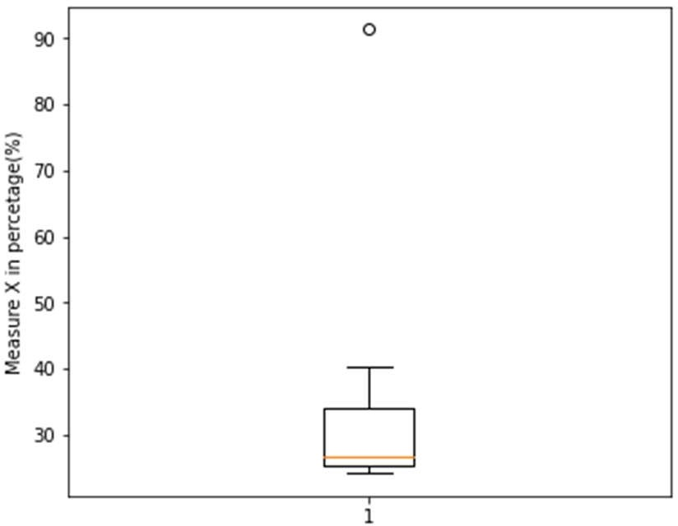

μ = 33.27% = 0.33

σ = 0.169454009

σ2 = 0.028714661

As per the calculation there is one outlier in given dataset and the value of outlier is 91.36%.

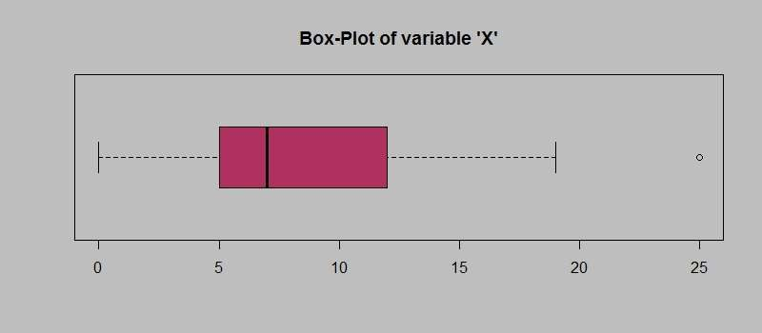

**Q2.** Answer the following three questions based on the box-plot above.

1. What is inter-quartile range of this dataset? (Please approximate the numbers) In one line, explain what this value implies.
2. What can we say about the skewness of this dataset?
3. If it was found that the data point with the value 25 is actually 2.5, how would the new boxplot be affected?

**ANS:**

1. Inter-quartile = Q3-Q1=12-5=7 Range from 5 to 12 and Viscous from 0 to 19, which contains 50% of data points.

There is a one outlier in given dataset, value of outlier is **25**

This value implies near to the median.

1. Positive skewed and mean is greater than median.
2. 2.5 will be not considered an outlier. The boxplot will start

from 0 and send at 20inrepresentation.

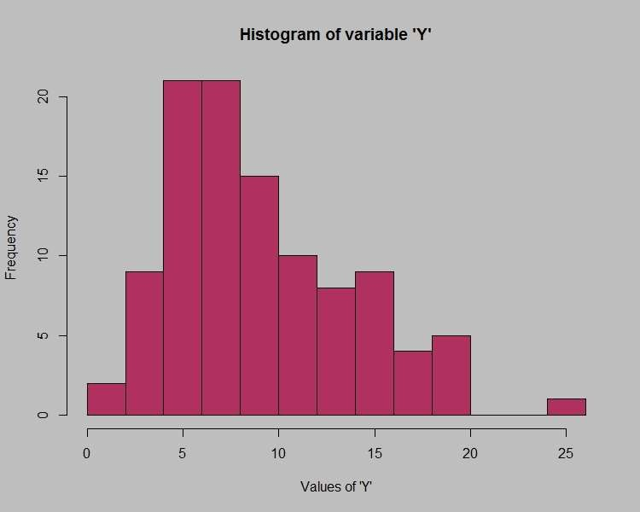

**Q3.** Answer the following three questions based on the histogram above.

1. Where would the mode of this dataset lie?
2. Comment on the skewness of the dataset.
3. Suppose that the above histogram and the box-plot in question 2 are plotted for the same dataset. Explain how these graphs complement each other in providing information about any dataset.

**ANS:**

* + 1. The mode of these data is lie between 4 to 8.
    2. This dataset is positive skewed.
    3. Median in boxplot and Mode in histogram

Histogram provides the frequency distribution so we can see how many times each data point is occurring however boxplot provides the quantile distribution i.e.50% data lies between 5 and 12.

Boxplot provides whisker length to identify outliers, no information from histogram. We can only guess looking at the gap that 25 may be an outlier.

**Q4.** AT&T was running commercials in 1990 aimed at luring back customers who had switched to one of the other long-distance phone service providers. One such commercial shows a businessman trying to reach Phoenix and mistakenly getting Fiji, where a half-naked native on a beach responds incomprehensibly in Polynesian. When asked about this advertisement, AT&T admitted that the portrayed incident did not actually take place but added that this was an enactment of something that “could happen.” Suppose that one in 200 long-distance telephone calls is misdirected. What is the probability that at least one in five attempted telephone calls reaches the wrong number? (Assume independence of attempts.)

**ANS:**

One in 200 long distance telephone calls are misdirecting so,

Probability of call misdirecting p = 1/200

Probability of call not misdirecting q = 1-1/200 = 199/200

Number of calls = 5

P(x) = nCx * px * qn-x

At least one in five attempted telephone calls reaches the wrong number

= 1- none of the call reaches wrong number

= 1-P (0)

= 1- 5C0 * (1/200)0 * (199/200)5-0

= 1-(199/200)5

= 0.0247

**Q5.** Returns on a certain business venture, to the nearest $1,000, are known to follow the following probability distribution.

|  |  |
| --- | --- |
| x | P(x) |
| -2,000 | 0.1 |
| -1,000 | 0.1 |
| 0 | 0.2 |
| 1000 | 0.2 |
| 2000 | 0.3 |
| 3000 | 0.1 |

* + 1. What is the most likely monetary outcome of the business venture?
    2. Is the venture likely to be successful? Explain
    3. What is the long-term average earning of business ventures of this kind? Explain
    4. What is the good measure of the risk involved in a venture of this kind? Compute this measure.

**ANS:**

1. **x=2000** at the probability of **0.3** is the Most likely monetary outcome of the business venture of given data.
2. Venture is successful when the X is positive.

In the data we can see, there are three positive values of X –

1000, 2000,3000 and probability of this values are – 0.2,0.3,0.1.

Probability = P (1000) + P (2000) + P (3000)

= 0.2+0.3+0.1

= 0.6

As 0.6 > 0.5 hence, venture likely to be successful as per calculation.

1. As per calculation, long term average earing of business ventures = 800 $.

Venture is likely to be positive as Expected values is positive

=800 $.

|  |  |  |
| --- | --- | --- |
| **E(X)** | **P(x)** | **E(X)** × **P(x)** |
| -2000 | 0.1 | -200 |
| -1000 | o.1 | -100 |
| 0 | 0.2 | 0 |
| 1000 | 0.3 | 200 |
| 2000 | 0.3 | 600 |
| 3000 | 0.1 | 300 |

Expected value = ∑ **E(X)** × **P(x) =** 800

1. The good measure of the risk involved in a venture of this kind,

P(loss) = P (x= -2000) + P (x=-1000) = 0.2.

So the risk associated with this venture is 20%.